Composer: Simple DiffusionDemo

# Change an “instanance”

In this example we want to change the schema to allow one to enter multiple phase for a given material.

1: At the Home screen navigate to “Composer”  
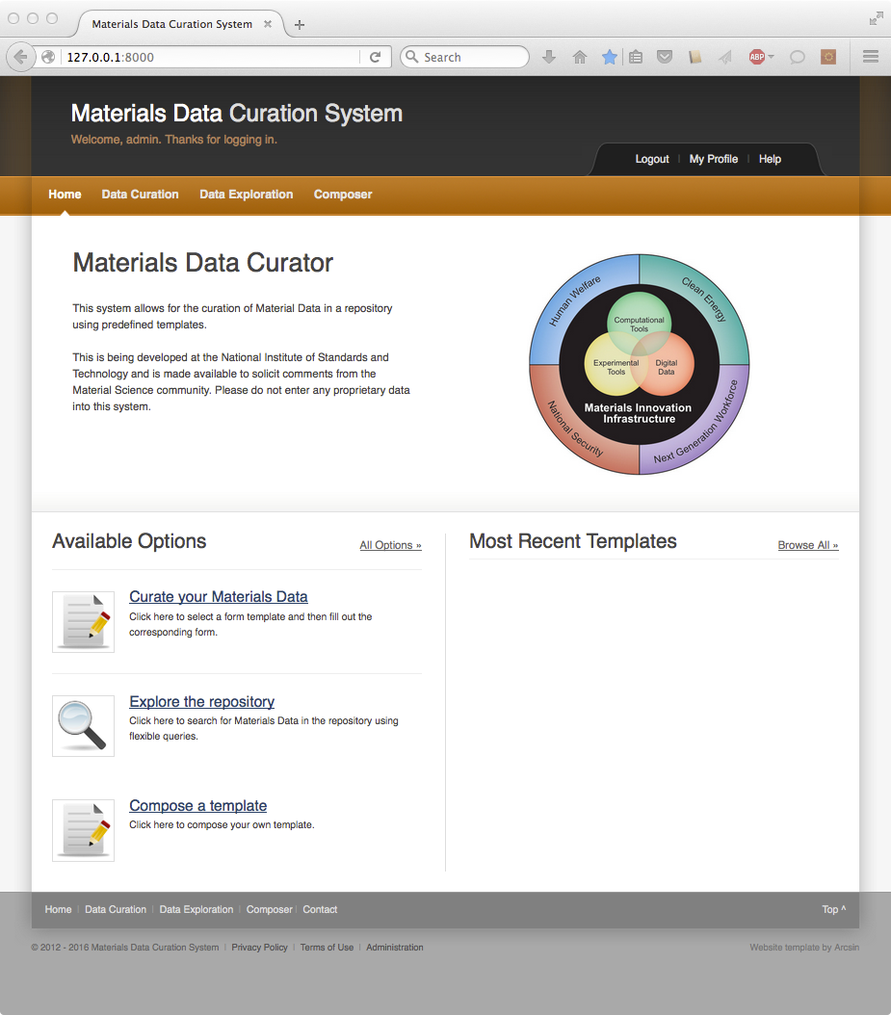

2: Select “DiffusionDemo” Template as the current template

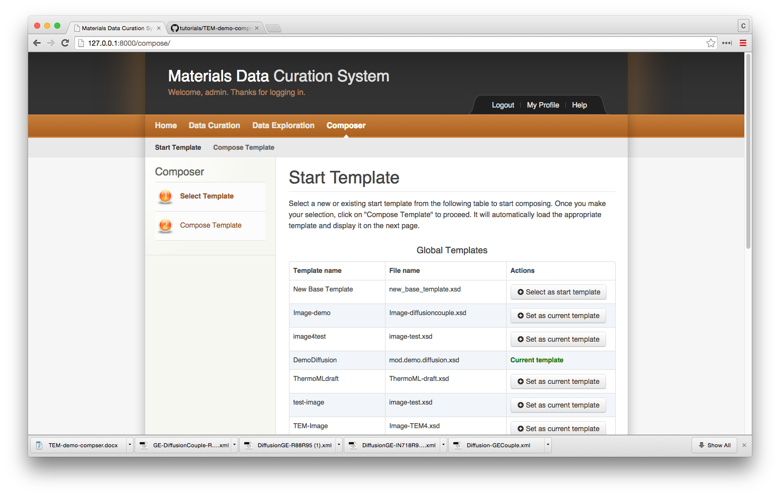

3: Select “Compose Template” on the left-side menu



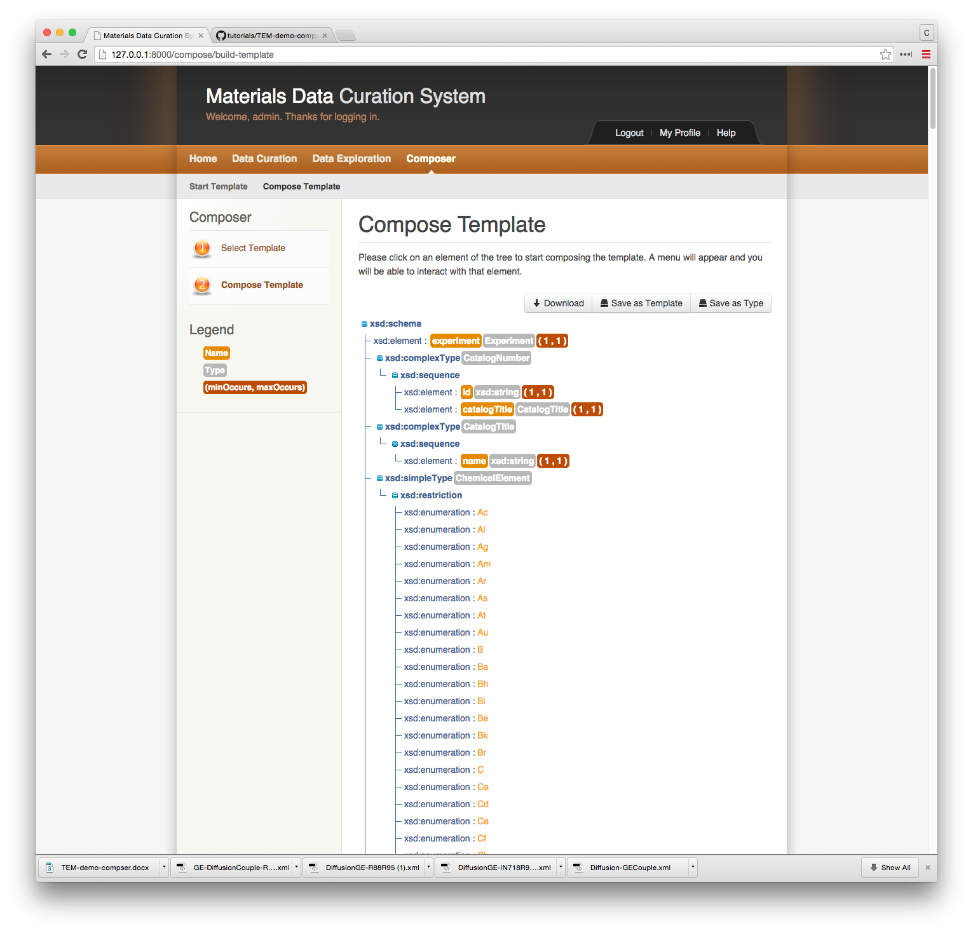

4. Scroll a little more than half way down the schema and find the “element” labelled “phase” and click on the element.

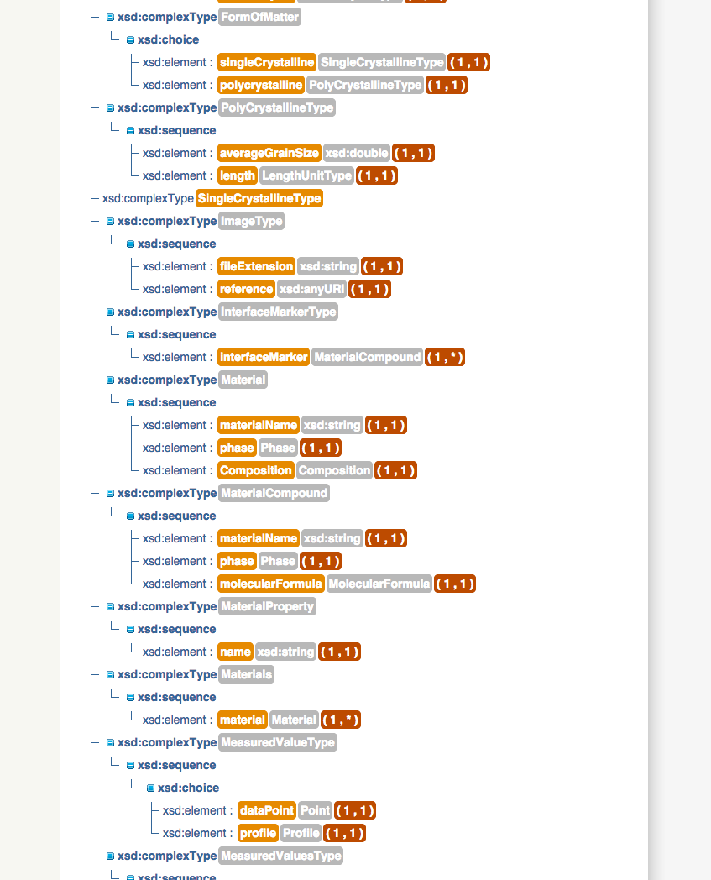

After clicking on “element” a box will appear with 3 choices: Rename, Manage Occurrences, and Delete. Select “Manage Occurrences”

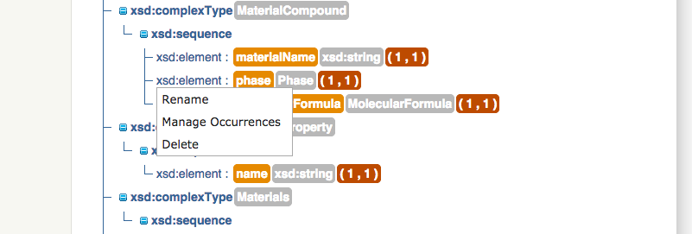

A new pop-up window will appear where you can change the number of occurrences that “phase” is allowed. Change it to “Unbounded” and click “Save”.

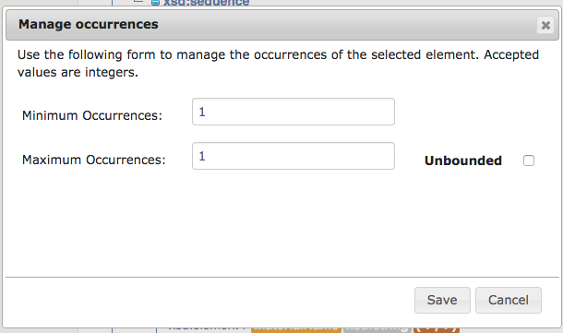

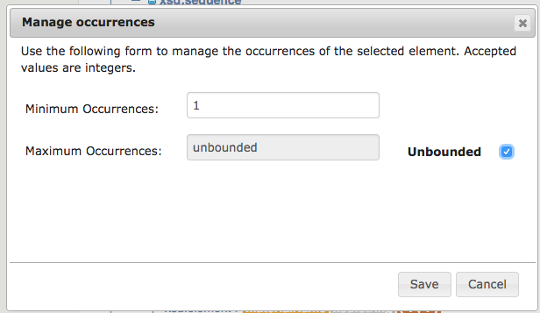

Now the number of occurrences for phase should be (1,*)

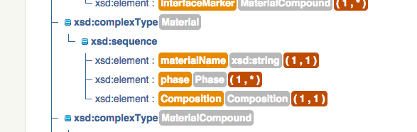

Now scroll to the top of the page and save the template as “DiffusionDemo-2”. 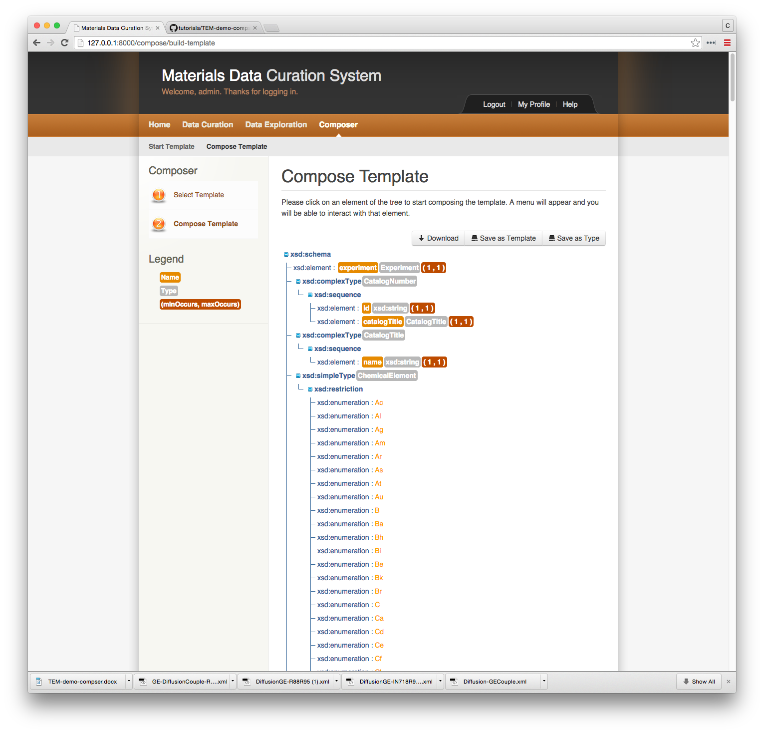

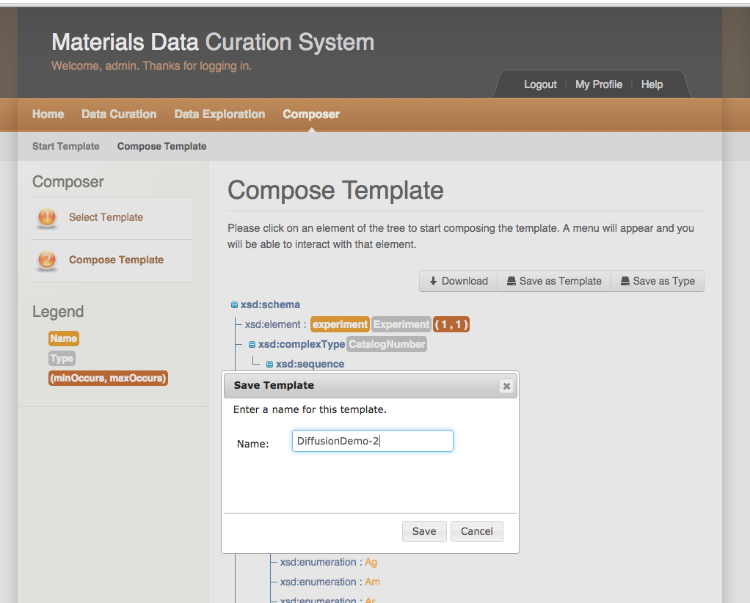

Now return to the “Data Curation” menu. You should now see under the “User Defined Templates” the DiffusionDemo-2 template.

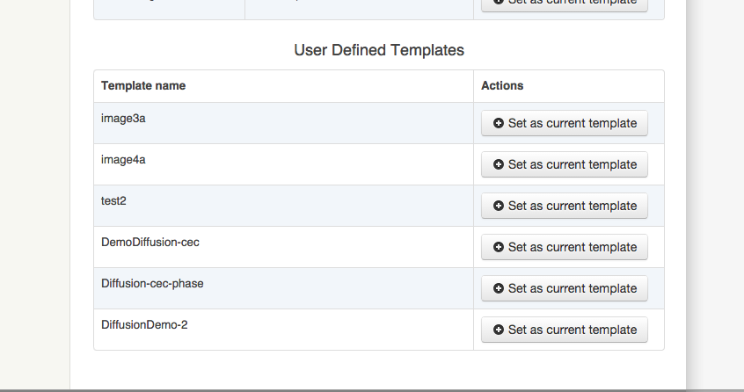

Select the template and read in the existing GE-DiffusionCouple-R88-IN100.xml document.

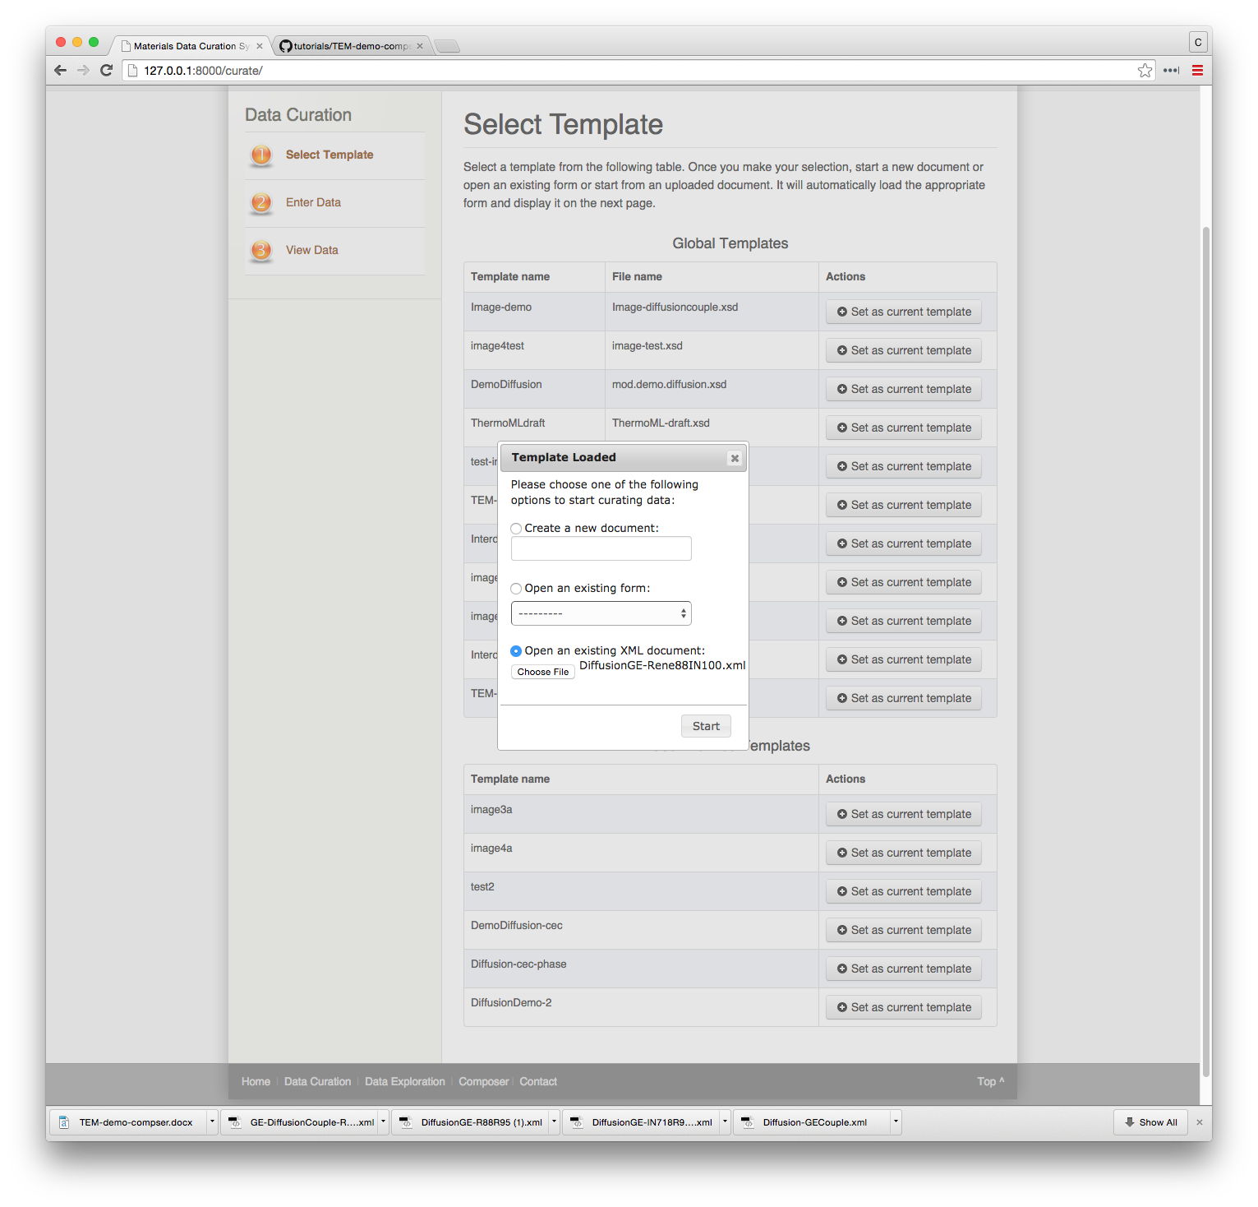

After reading the “GE-DiffusionCouple-R88-IN100” document, the Data Entry screen will appear. Notice there is now a “green” plus button next to phase. Click on it to add additional phase to the Rene-88 material.

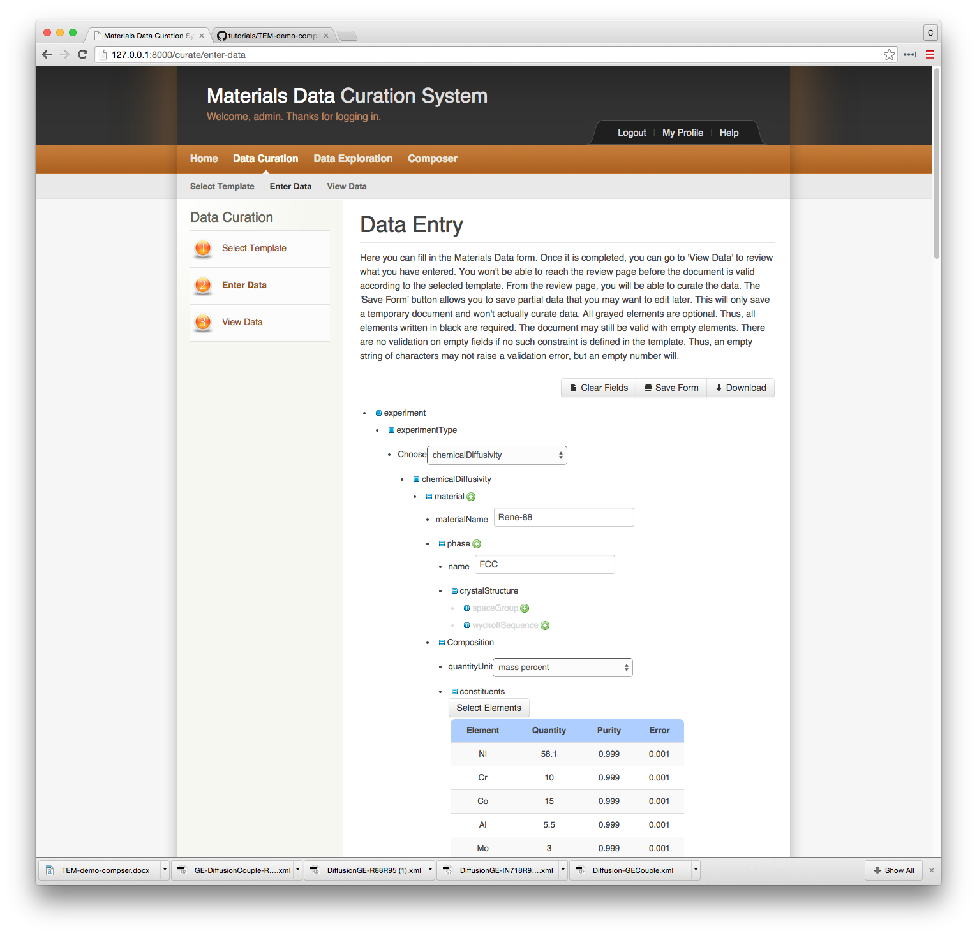

Enter the “MC carbide” as a second phase.

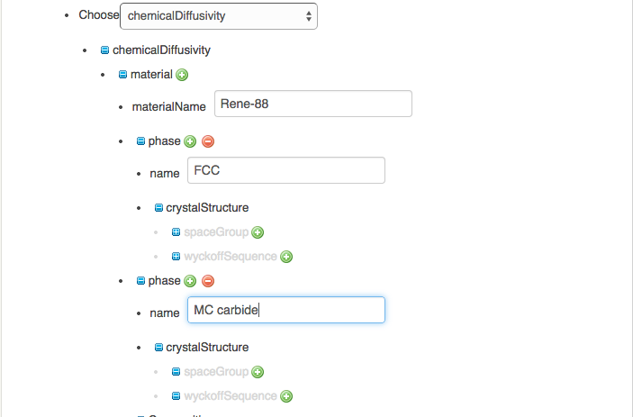

# Modifying an existing Template

1: Click on “Composer”  
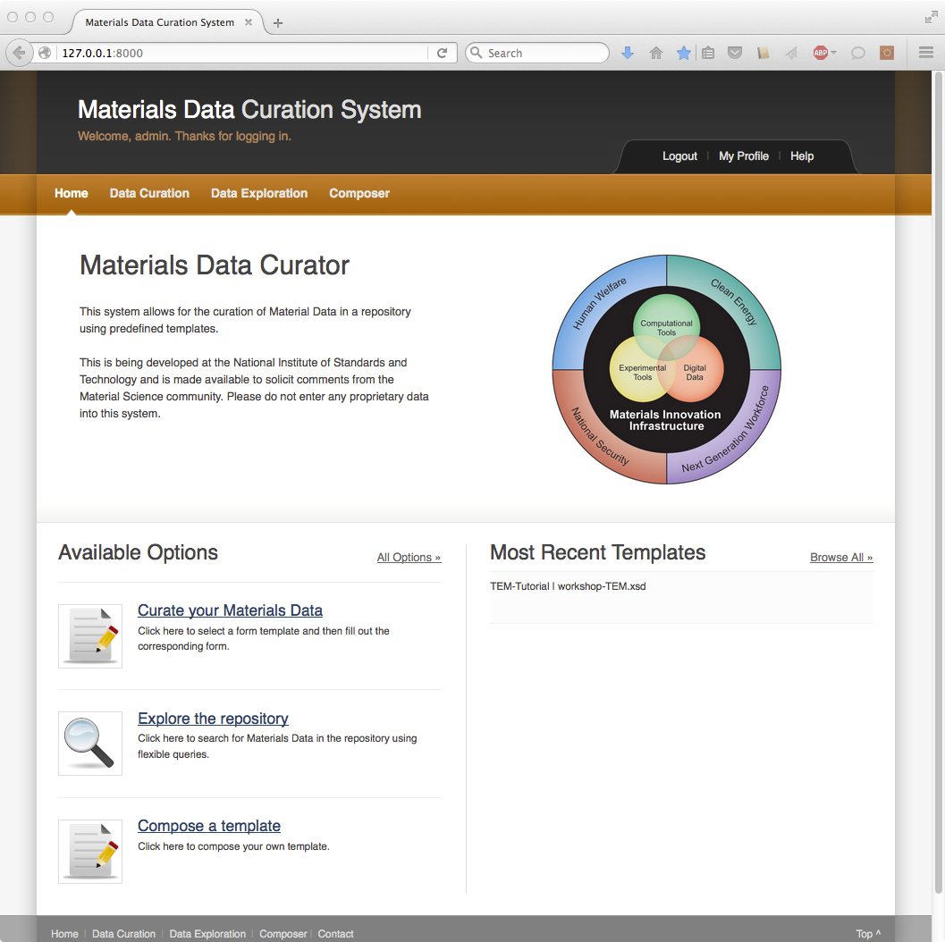

2: Select “TEM-Tutorial” as current template. Proceed to second step: “Compose Tempalte”  
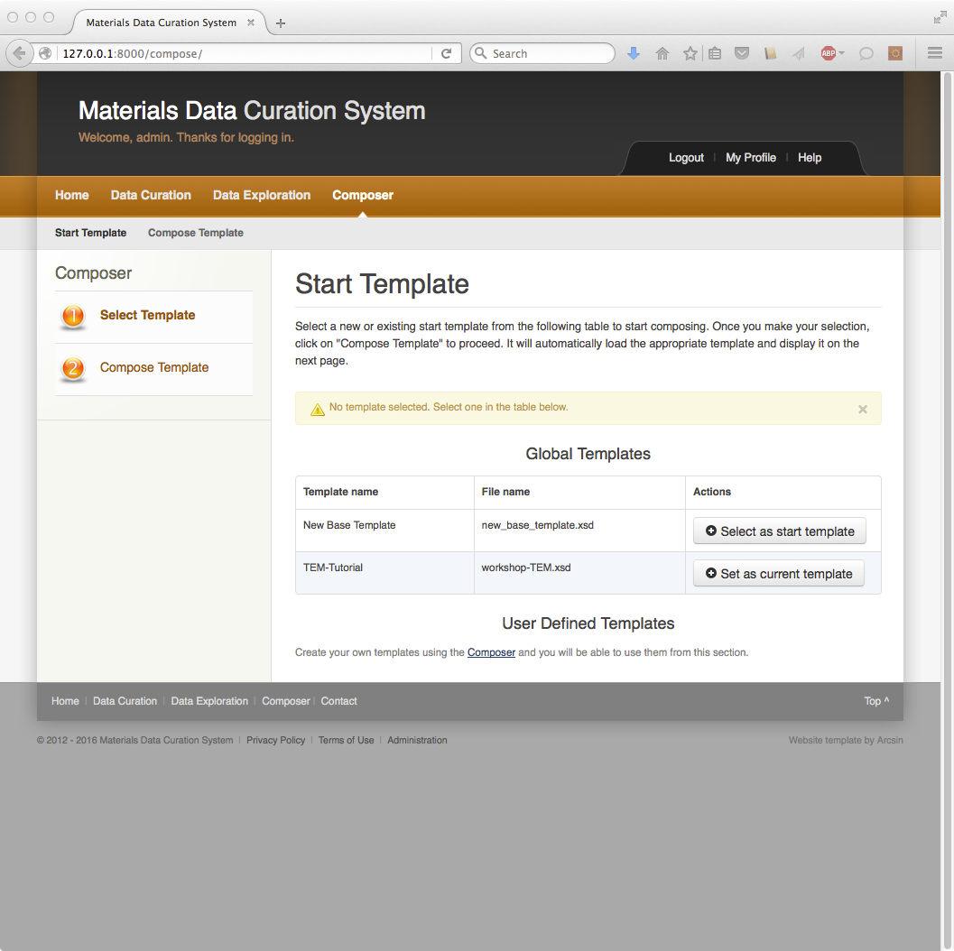

3: Click on the top-level xsd:sequence and select “Add Element”  
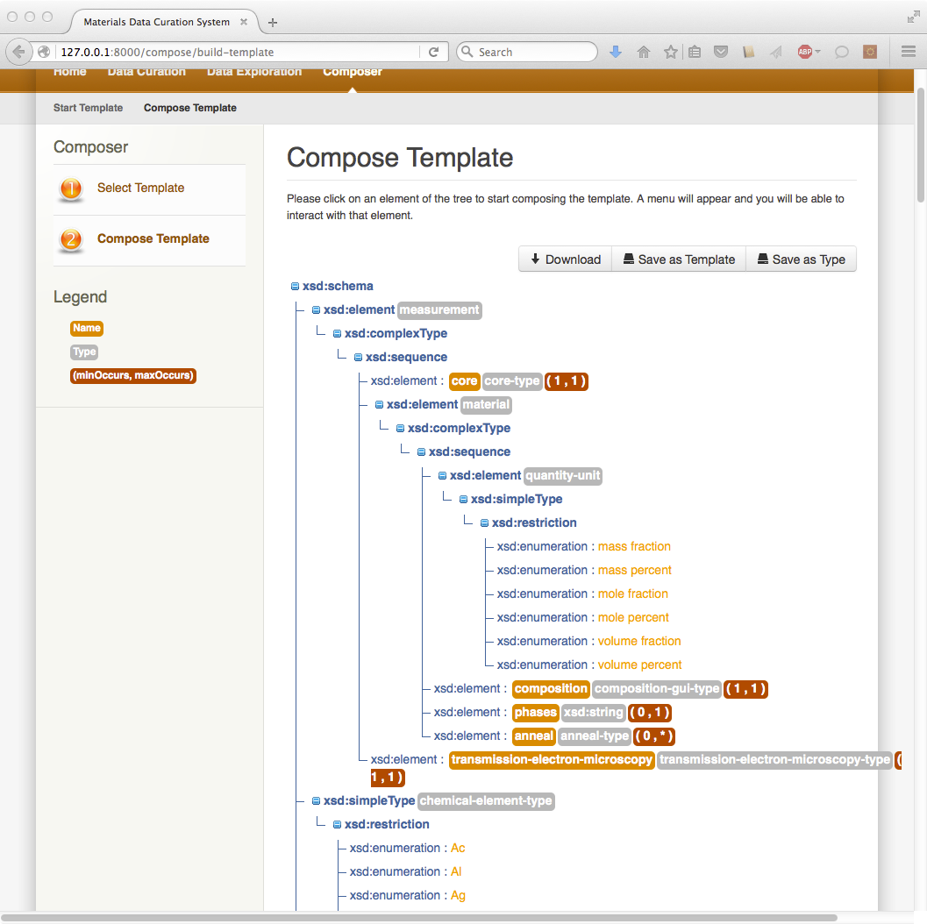

4: Drop-down “No Buckets” menu and insert “note”  
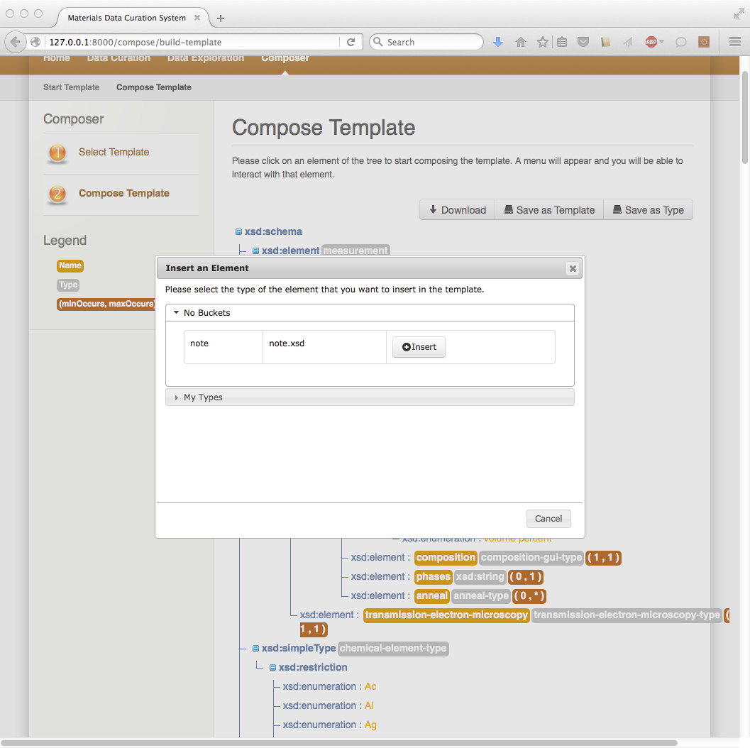

5: Notice new element  
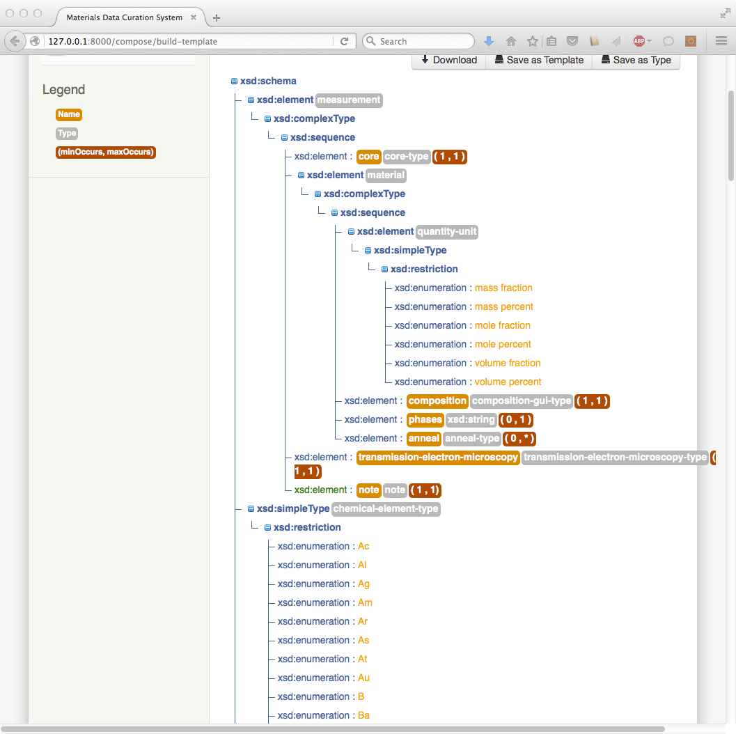

6: Scroll to the top and click “Save as Template”. Enter “TEM note” and click “save”.  
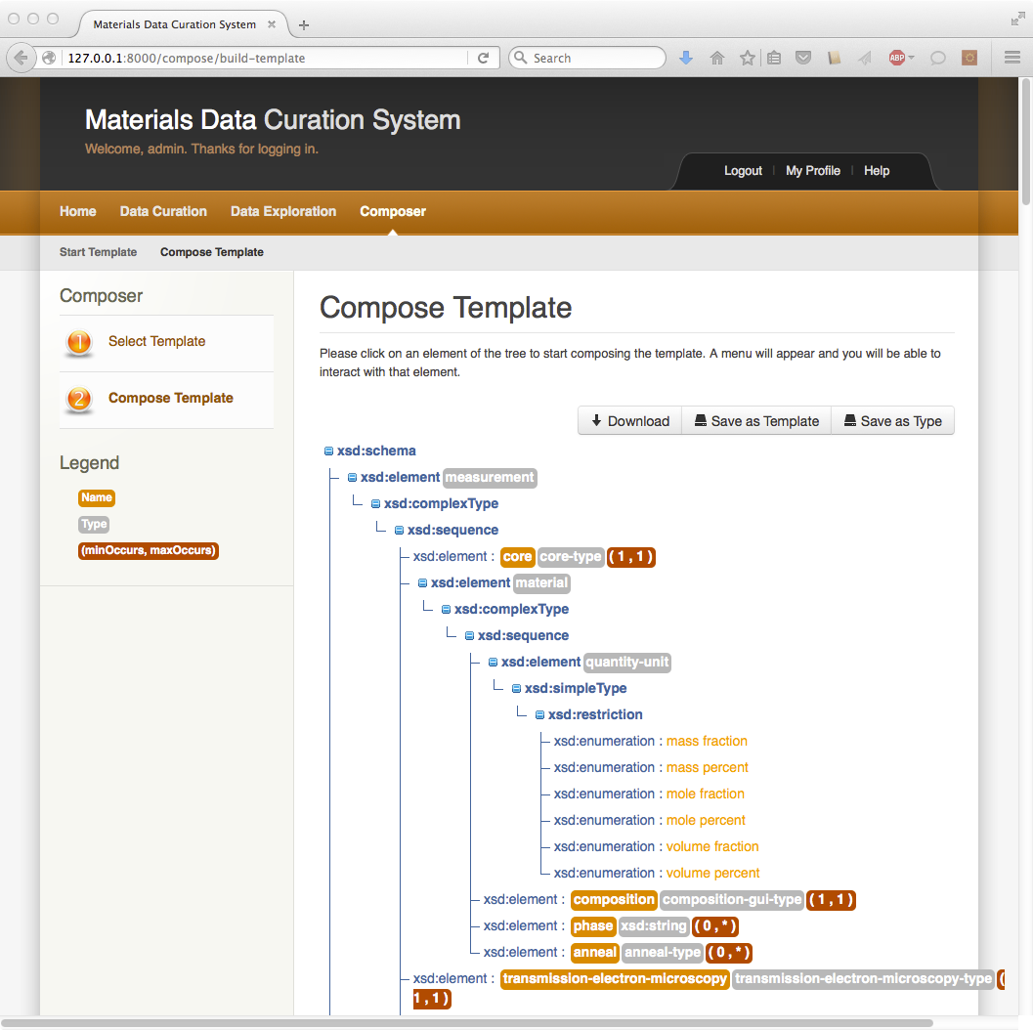

7: After selecting “Ok” click “home”  
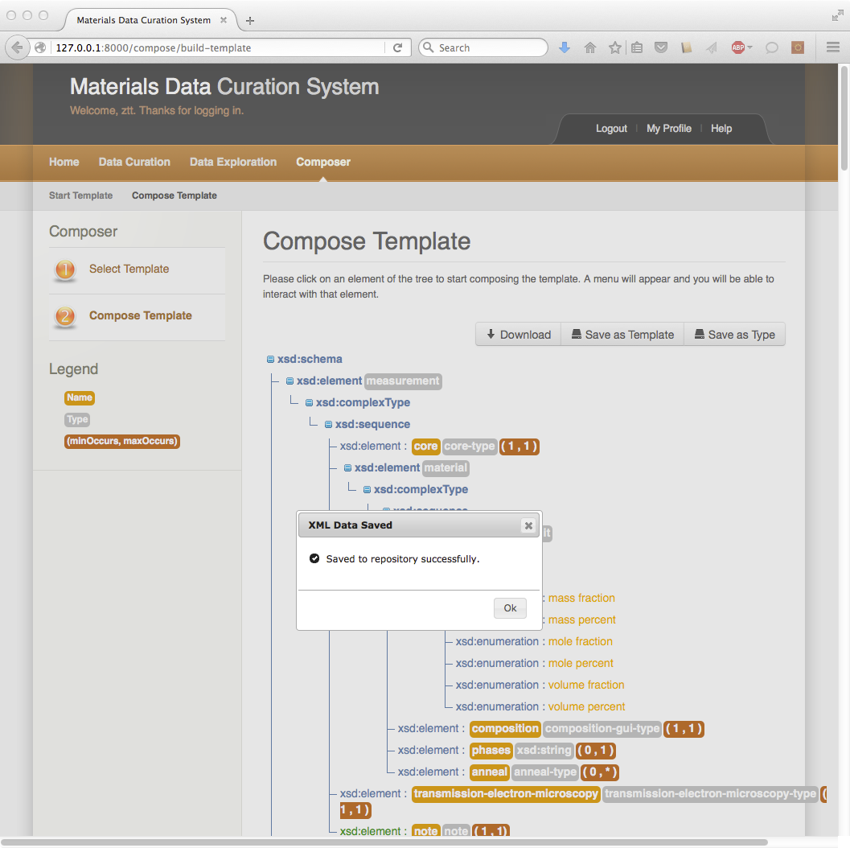

8: Click on “Data Curation” and set “TEM note” as the current template  
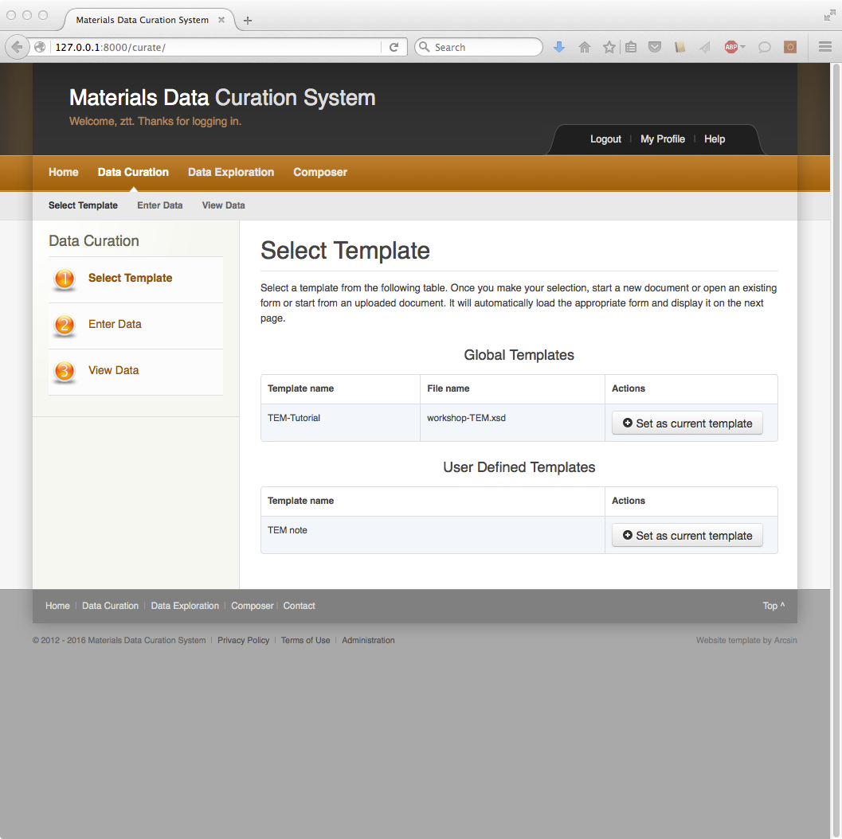

9: Select “Create a new document”. Enter “test-interface” and click “Start”. Verify “note” element was added to the template.  
